**Day 22 – IPL Winning Streak**

***Problem Statement:***

Given table has details of every IPL 2023 matches. Identify the maximum winning streak for each team.

*Additional test cases:*

1) Update the dataset such that when Chennai Super Kings win match no 17, your query shows the updated streak.

2) Update the dataset such that Royal Challengers Bangalore loose all match and your query should populate the winning streak as 0

***Input***:

*Table1: ipl_results*

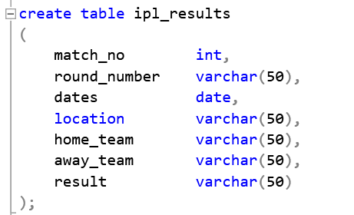

*ExpectedOutput:*

|  |  |
| --- | --- |
| **EXPECTED OUTPUT** | |
| **TEAMS** | **MAX_WINNING_STREAK** |
| Lucknow Super Giants | 3 |
| Chennai Super Kings | 3 |
| Mumbai Indians | 3 |
| Gujarat Titans | 3 |
| Rajasthan Royals | 3 |
| Sunrisers Hyderabad | 2 |
| Royal Challengers Bangalore | 2 |
| Delhi Capitals | 2 |
| Kolkata Knight Riders | 2 |
| Punjab Kings | 2 |

**SOLUTION**

With teams_cte

as(

select home_team as teams from ipl_results

union

select away_team as teams from ipl_results

),

teams_id_cte

as(

select dates,teams,result,row_number() over(partition by teams order by teams,dates) as rn

from teams_cte as tc

join ipl_results as ir on tc.teams=ir.away_team or tc.teams=ir.home_team

)

,teams_diff_cte

as(

select *, rn - ROW_NUMBER() over(partition by teams order by teams,dates) as diff

from teams_id_cte

where result = teams

),

teams_final_cte

as(

select teams, COUNT(diff) oveR(partition by teams,diff order by teams,dates) as cnt

from teams_diff_cte

)

select tc.teams,isnull(MAX(cnt),0) as max_winning_streak

from teams_cte as tc left join teams_final_cte as tfc on tc.teams=tfc.teams

group by tc.teams

order by max_winning_streak desc

To test the additional cases – Update the dataset

-- Update dataset to test result

update ipl_results

set result='Chennai Super Kings'

where match_no=17;

update ipl_results

set result='Mumbai Indians'

where match_no=5;

update ipl_results

set result='Delhi Capitals'

where match_no=20;

update ipl_results

set result='Punjab Kings'

where match_no=27;

update ipl_results

set result='Rajasthan Royals'

where match_no=32;

update ipl_results

set result='Lucknow Super Giants'

where match_no=43;

update ipl_results

set result='Rajasthan Royals'

where match_no=60;

update ipl_results

set result='Sunrisers Hyderabad'

where match_no=65;

***OUTPUT***

